Cycling Networks & Filtered Permeability – Notes from Tour of Northern Europe

The following notes summarise observations made by Steve Melia on a cycling tour of 3,000 km through six countries of north-west Europe from late June to early September 2008. This followed similar tours during 2006 (through France to Freiburg) and 2007 (through the Netherlands). It also draws on Ligermoet (2006) and Pucher and Buelher (2007), which give more information on Odense, Copenhagen, Muenster and several other German and Dutch cities.

Contents Page
1. Filtered Permeability 1
2. Denmark – General 1
a. Odense 3
b. Copenhagen 5
3. Germany – General 6
a. Muenster 6
4. Netherlands – Maastricht 8
5. Belgium – General 9
a. Regional Cycle Networks 9
b. Hasselt 10
6. Sweden – Malmö 11

- Filtered Permeability

The term ‘filtered permeability’ (a new name for a concept which has been around in various forms for a long time) was coined in a couple of articles (Melia 2007 & 2008) and has since been defined in the CLG/TCPA (2007) transport guidance for Eco-towns as:
“separating the sustainable modes from private motor traffic in order to give them an advantage in terms of speed, distance and convenience.”

Despite this ‘official’ endorsement, the principle runs counter to the prevailing wisdom in the UK, as codified in Manual for Streets, which seeks to avoid separation and maximise permeability for all modes, including private motor vehicles.

The two previous tours indicated that this principle, described in slightly different ways, was central to the transport planning of cities such as Freiburg and Groningen, which have been particularly successful in promoting cycling and restraining car use. One objective of the 2008 journey was to look for evidence (and absence) of this principle elsewhere in north-western Europe.

- Denmark – General

The standard of cycling facilities in Denmark, is considerably better than in the U.K. and most of Western Europe, but is not as high or consistent as in the Netherlands (policy makers from Denmark have visited the Netherlands in the past in order to learn from the Dutch experience). This is consistent with the statistical comparison within Pucher and Buelher (2007), which shows the top countries in Europe for cycling as:

Netherlands 27%
Denmark 18%
Finland 11%
Sweden 10%
Germany 10%
Belgium 8%

These statistics were drawn from a number of sources. The Danish figures date from 2001. Nana Henriques, the Cycling Officer for Odense told me that national rates of cycling have fallen “by 30% over the past ten years”.

Standards of facilities and rates of cycling within the main cities, discussed below, are comparable to Dutch and the best of German practice, but elsewhere, the standards are generally lower and whatever the reasons there are far fewer cyclists than in comparable places in the Netherlands.

Denmark’s population density, and the traffic on its roads, are considerably lower than the Netherlands or England, so there is less need for segregation outside of the main urban centres. Having said that, the standard of segregation along main roads is generally better than most countries, but not as consistent as the Netherlands. A wide shared pavement along both sides of a National road is typical, though there are sometimes discontinuities. Such paths usually have priority over side roads, indicated by markings across the side road. On main roads outside the urban areas, where cyclists are infrequent, these markings are not always immediately respected by drivers. If a driver has crossed the line and sees a cyclist approaching, he will often reverse, acknowledging his error. Opportunities to cross main roads are often limited, so shared and hybrid cycle paths on main roads outside the cities are often bi-directional.

On main roads within smaller towns, cycle lanes, sometimes protected as illustrated on figure 1, are typical (rather than the Dutch-style hybrid paths).

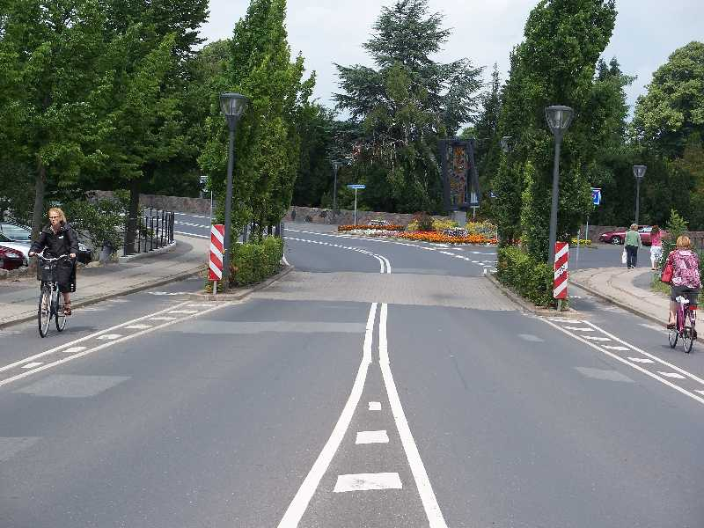 | 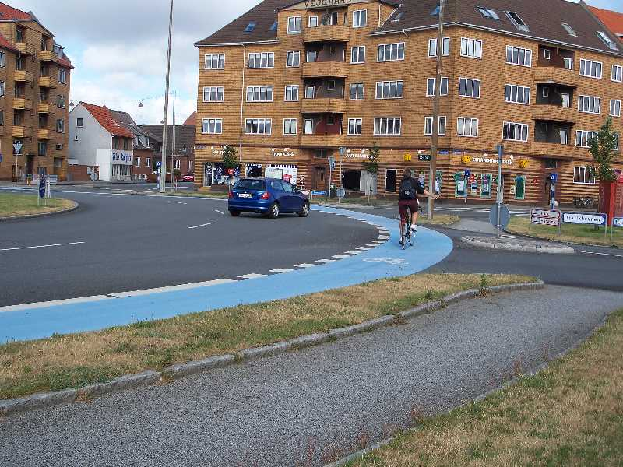
1 Small Town Cycle Lane | 2 Roundabout, Esbjerg

One peculiarity of cycling practice in Denmark, which has influenced the design of many facilities, relates to left turns. Cyclists are supposed to cross the junction on the right hand side, raise one arm to show they are stopping, then wait for a traffic light or an opening to cross both carriageways at once. Moving to the middle of the road before turning is apparently an offence, although a minority of cyclists do break this rule, and I did not notice any of them being stopped by the police.
Henriques told me there had been a spate recently, particularly in Copenhagen, of cyclists being killed by lorries turning right across them. Whether the ‘stay right’ policy has contributed to this problem could merit some further analysis.

This principle of cyclists staying on the right hand side is maintained at roundabouts where arrangements such as that shown on figure 2 are quite common. Drivers have come to expect cyclists on their right, and always gave way in my experience.

Planning policies may have contributed to the fall in rates of cycling (and increases in car use and dependency). The density of new development was very low almost everywhere outside the main cities, with large bungalows or dormer-bungalows surrounded by large gardens (see figure 3) very common.

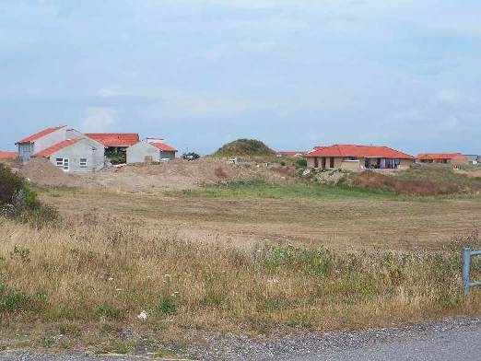 | 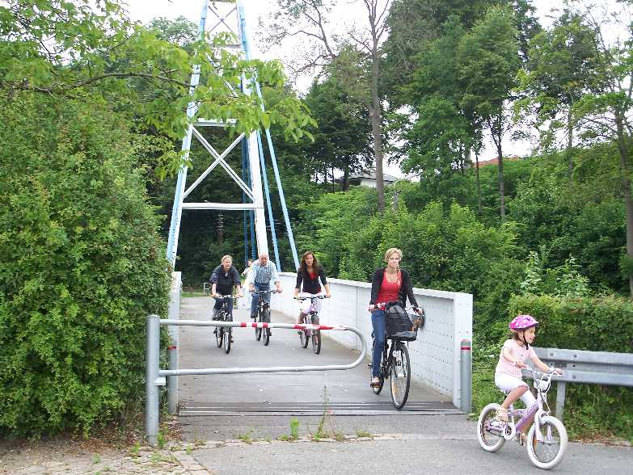
3 Low Density Development – Rural Zealand | 4 Bridge on National Cycle Network

There is a well developed network of national and regional cycle routes, which seem mainly aimed at leisure riders. Following them, does usually ensure a degree of continuity, with links such as the bridge shown in figure 4, helping to cross or avoid main roads or other obstacles.

Again, unlike the Netherlands, some of the longer bridges carrying motorways between Denmark’s main islands do not provide for cyclists. To cross from Fyn and Zealand (between Odense to Copenhagen) cyclists must take a train. These are half hourly during the day with considerable capacity for bikes, but like many things in Denmark, expensive: a one-way ticket cost about £12, of which about £3 was for the bike.

  - Odense

Odense is Denmark’s third city, with a population of 180,000. Between 1999 and 2002 it was designated as the country’s first ‘cycling city’, due in large part to the efforts of the former highway engineer and cycling officer, Troels Andersen. His successor, Nanna Henriques, comes from a public information background, reflecting the emphasis put on social marketing of cycling there. The various programmes aimed at children, middle aged men, older people are described in Pucher and Buelher (2007).

Rates of cycling increased by 80% to 25% of all trips in 2002. These statistics were based on manual counts at different points around the city. Since then, according to Henriques, rates in Odense have remained stable, whilst they have plummeted elsewhere. She was basing this statement on the cycle trip counters in the city centre (figure 5). Whether the same situation was true in the suburbs she was unsure.

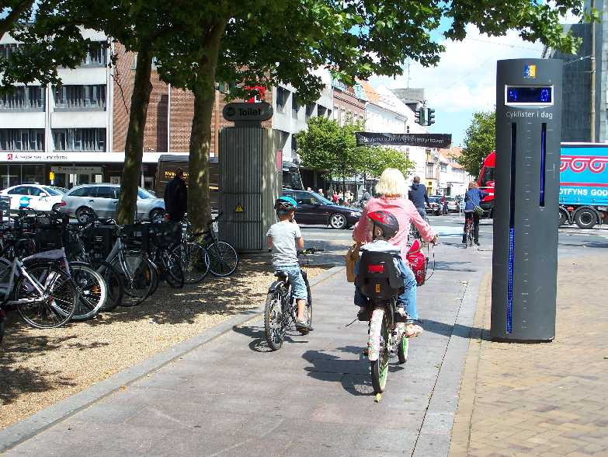 | 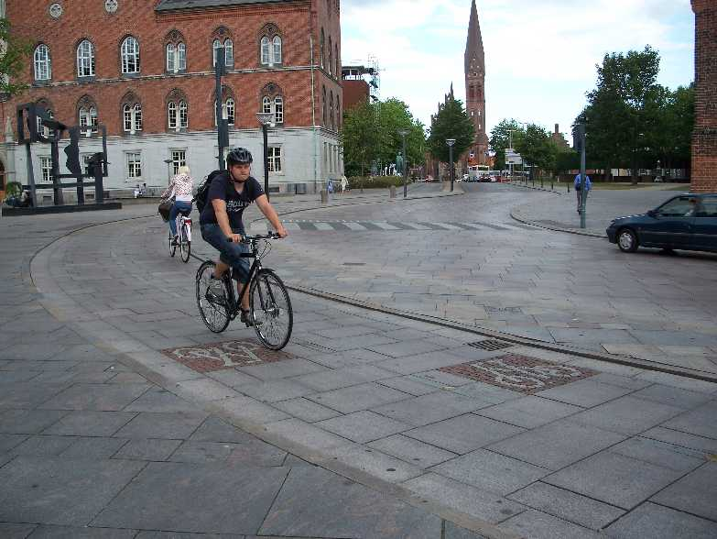
5 Odense Cycle Trip Counter | 6 Odense City Centre Cycle Route

Segregated facilities such as that shown in figure 6 have proliferated in recent years, particularly in the City Centre. Much of the centre is pedestrianised, and there are plans to extend this, with a new tram system by 2014. As with most of the ‘cycling cities’ I have visited, it is not possible to drive through the centre in a car.

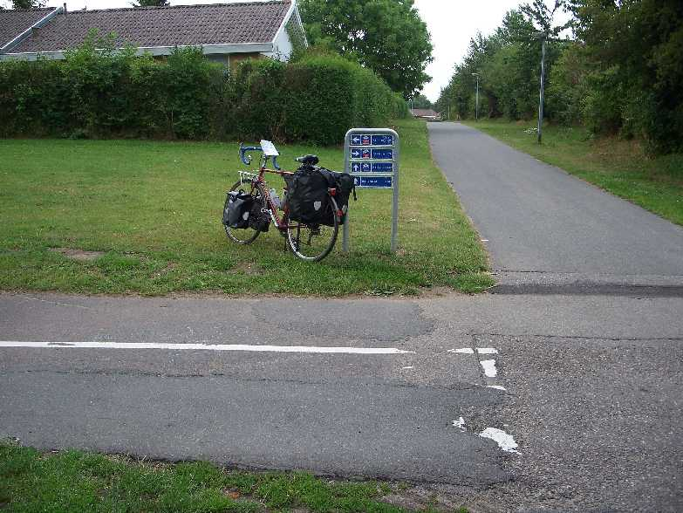
7 Odense, suburban cycle network

Apart from the progressive removal of cars from the city centre, Henriques did not recognise the concept of filtered permeability. The blocking of through routes described below has not been a specific policy in Odense. Having said that, when the leaving the city through the suburbs, I followed a cycle network (figure 7) which appeared to link several housing estates, running behind estates with no through road for vehicular traffic in that direction. The principles of urban intensification – evident in Copenhagen, were not generally followed in Odense, whose suburbs are continuing to expand.

As an aside, I explained to Henriques that the prevailing wisdom in Britain, codified in Government policy and supported by most cycling activists, is that cycling should take place on unsegregated roads wherever possible. As I found in similar discussions in the Netherlands, she found this a strange attitude: in Denmark, it is believed that to encourage cycling requires a network of separate facilities which not only are safe but are also perceived to be safe and comfortable (see Pucher and Buelher).

We looked at the Warrington Cycle Campaign’s ‘facility of the month’ website. It would be difficult to find similar examples in Denmark, although I did encounter some in Belgium and Northern France.

  - Copenhagen

Nearly a quarter of Denmark’s 5 million people live in Greater Copenhagen, and the contrast in levels of activity between the capital and the rest of the country is unusually stark. Odense feels like a village in comparison.

Rates of cycling are continuing to rise in Copenhagen representing 20% of all journeys in 2005 (Pucher and Buelher, 2007). On main roads the planners there have a strong preference for separate paths over on-street lanes – see figure 8. The Dutch style hybrid paths are easier to implement whether there is a ‘stay right’ rule. This means at every junction there needs to be some facility for cyclists to cross – usually in the form of separate traffic lights.

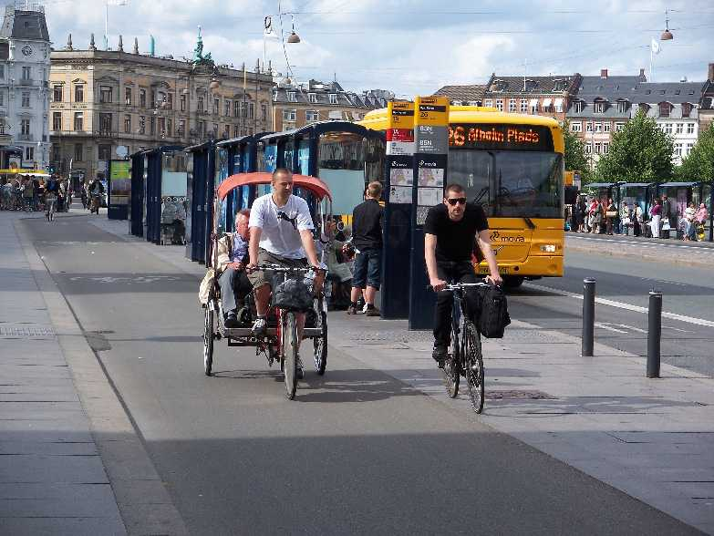 | 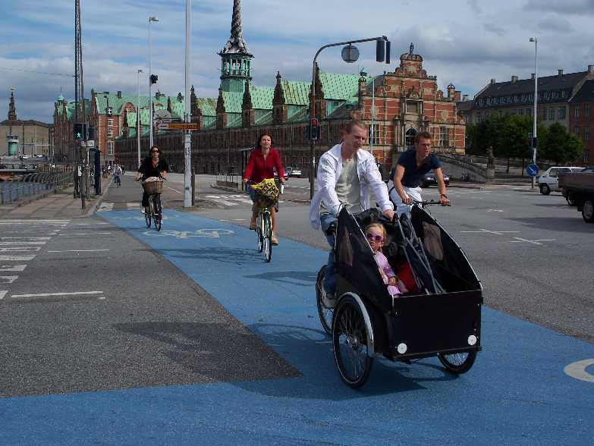
8 Copenhagen cycle path | 9 Copenhagen junction

The principle of separate provision is not possible everywhere within the city centre. Some of the cobbled streets are not pleasant to negotiate on a road bike. Although it does not appear to be a systematic principle, there was some evidence of filtered permeability e.g. figure 10

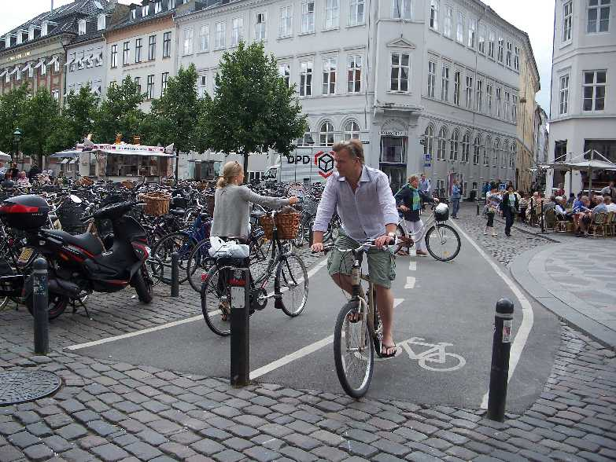 | 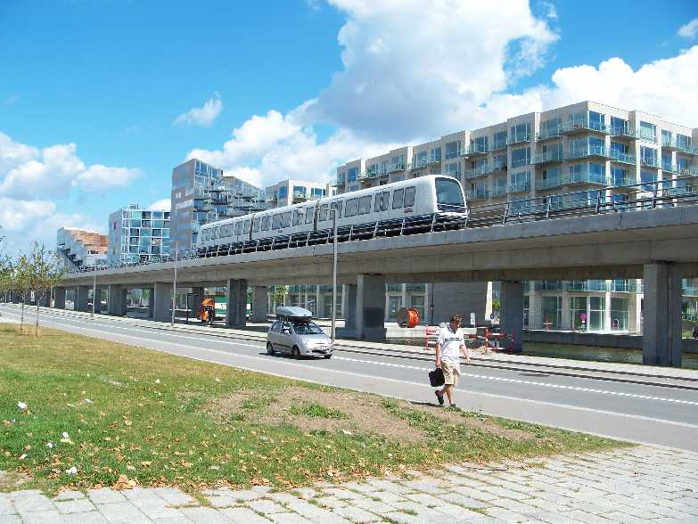
10 Filtered Permeability in Copenhagen City Centre | 11 Amager growth area and Metro

Unlike the rest of the country, new residential development in Copenhagen is taking place at very high densities. The island of Amager is the growth area, served by a new Metro system (which runs 24 hours a day and accepts bikes) the new regional trains to Malmo in Sweden, and a comprehensive network of hybrid cycle paths.

The cycle route leaving Copenhagen via Amager towards the South, connects with a highly developed network of separate routes, mainly through parks and nature reserves, eventually (after about 15km) joining a main road with a hybrid path. These routes enable cyclists to enter and leave the city entirely avoiding motor traffic.

- Germany – General

Cycling provision and rates of cycling vary considerably across Germany. Certain cities, such as Freiburg and Muenster (described below) compare with the best of European practice, but elsewhere both the quality of facilities and rates of cycling are variable. German planners make considerable use of shared pavements, which are often uneven, not well designed for cycling, and compulsory, as drivers will often point out aggressively if cyclists fail to use them.

  - Muenster

Muenster (population 278,000) is “Germany’s No.1 cycling city”, with rates of cycling increasing to 35% of journeys by 2001 (Ligermoet, 2006). It has approximately 60,000 students and its terrain is fairly flat.

Unlike a number of German cities of similar size, Muenster has no tram or metro system. The share of local public transport – essentially buses – at 11% is lower than cities such as Freiburg. The city centre is substantially pedestrianised and closed to through traffic.

Ligermoet (2006) and Pucher and Buelher (2007) describe the comprehensive strategy which has supported the growth in cycle use in Muenster. The cycling network is comparable in quality and comprehensiveness to Dutch cities, with one difference. Although policy aims to provide separate space for cyclists and pedestrians, often using separate paths, following usual German practice, on-street cycle routes are often built into the pavements on the same level, as shown on figure 12. Both cyclists and pedestrians tend to treat the whole surface as a shared space in those circumstances, whereas the hybrid paths (e.g figures 6 and 8 above) lead to greater segregation.

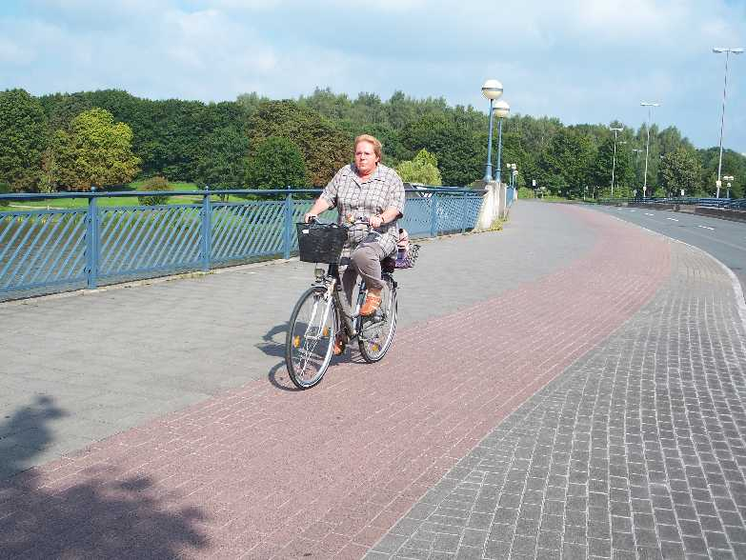 | 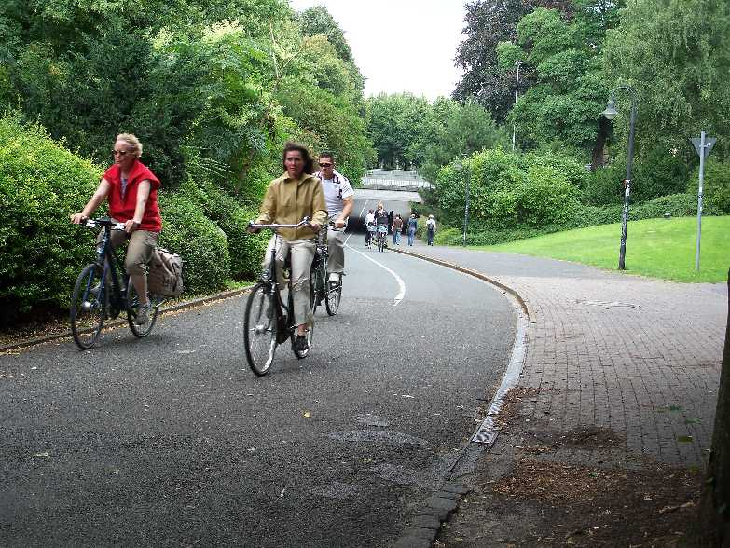
12 – Cycle path flush with pavement | 13 – Muenster Promenade

The centre-piece of Muenster’s cycle network is the Promenade an ‘inner ring-road’ open only to cyclists and pedestrians. It is full road width with one or two separate pavements on either side. Although some pedestrians walk on the central path, cyclists are able to make more rapid progress than in conventional shared paths or shared space streets. Its intersections with the radial roads use traffic signals and some underpasses (figure 13).

Filtered permeability is an important principle of transport management in Muenster, not only in the centre, but across the city as a whole. One aspect of this policy is described by Pucher and Buelher as follows:

“car travel is often detoured by artificial dead ends and deliberate street blockages of various soughts, reducing the speed and convenience of car travel.”

Many examples of this policy were visible across the city, sometimes using bollards (e.g. figure 14). In some places (e.g. figure 15) it appeared part of a policy to reclaim road space as part of the public realm.

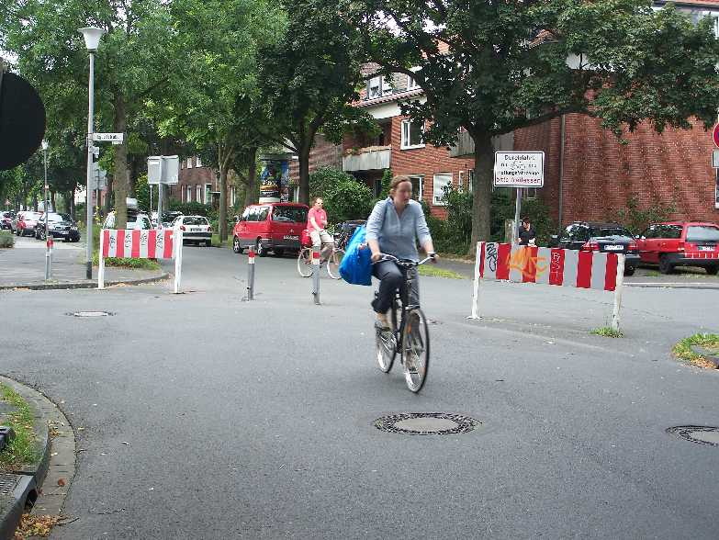 | 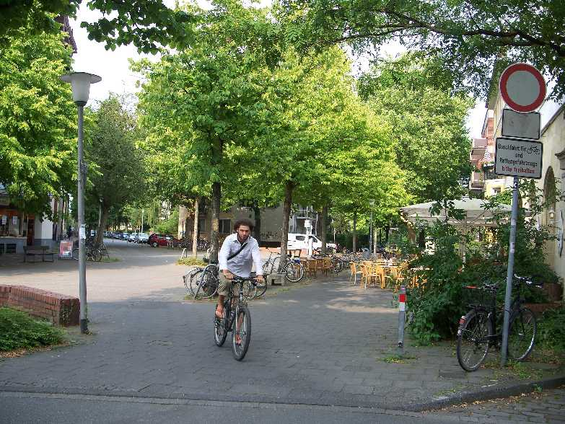
14 – Bollarded street | 15 – Reclaimed street space

The full panoply of means to create shortcuts for cyclists and pedestrians can be seen across Muenster, including its suburbs e.g. separate paths, bridges, underpasses, false one-way streets etc.

The area around Muenster North railway station provides an interesting mini case study of how filtered permeability is achieved there. Muenster North is on the edge of the city, 2.5km from the centre. The western side of the station was mainly employment area, the eastern side mainly residential. On figure 16 the blue lines are the cycle network, some of which are on segregated paths (often as wide as a road) and some on roads closed to through traffic. The red crosses indicate key points where pedestrians and cyclists are allowed through, and motor vehicles are not. A small car park and Covered cycle parking is provided at the station (figure 18), which is also a nodal point for buses. Observing the station around the evening rush hour, the largest proportion of station customers arrived on foot, followed by cyclists. Relatively few appeared to use cars or buses.

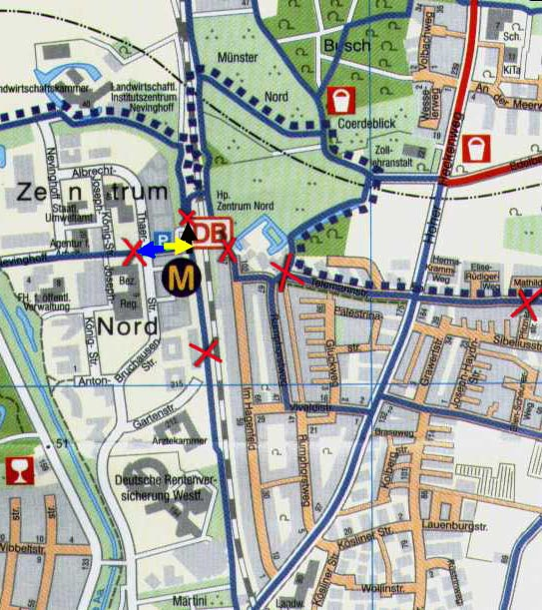  16 – Muenster North | 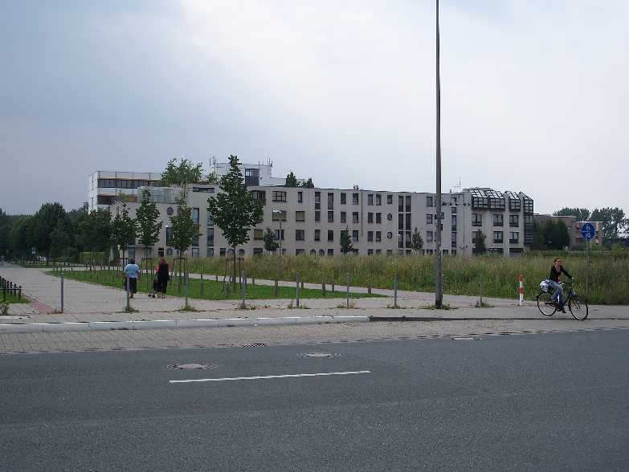  17 – Employment Area near Muenster North Station (blue arrow on figure 16)  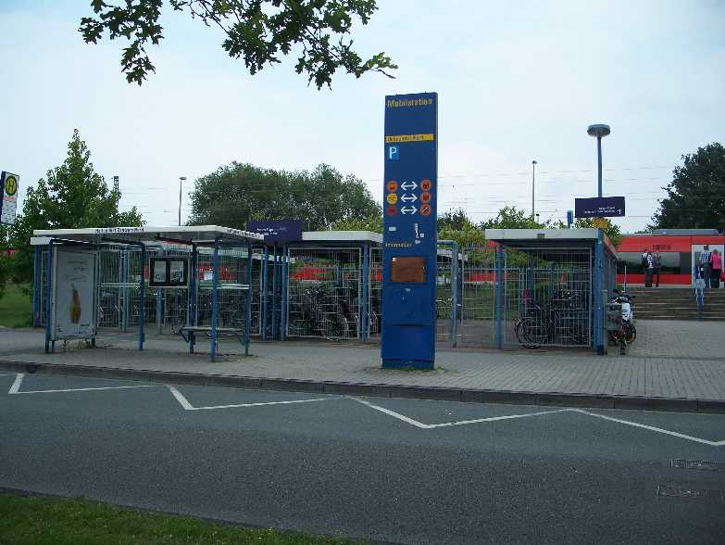
 | 18 Muenster North Station (yellow arrow)

- Netherlands – Maastricht

I passed briefly through the Netherlands on this trip, crossing the narrow stretch of Limburg province which includes Maastricht, where I stayed for one evening only.

As Dutch transport planners told me last year, Limburg province, the only part of the Netherlands which is not flat, has a relatively lower level of cycle use than the rest of the country. The cycling network appeared to follow the usual high Dutch standards, however, and within Maastricht itself, cycle use appeared to be high.

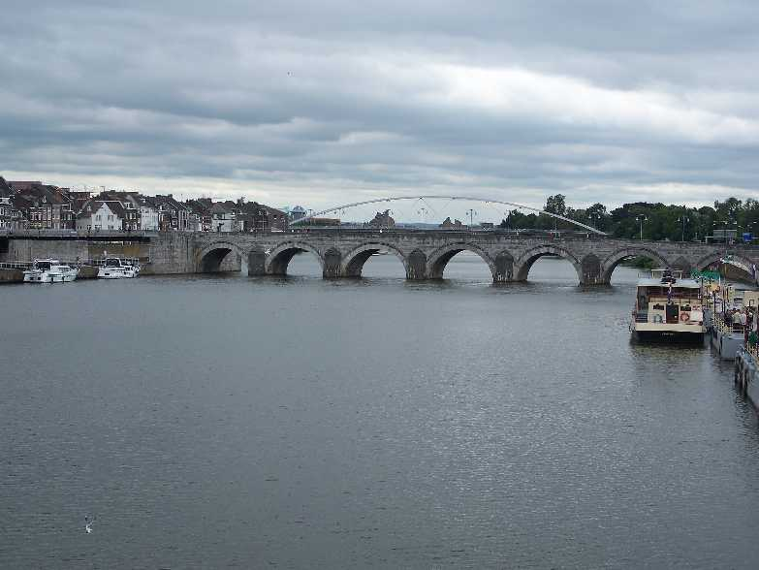 | 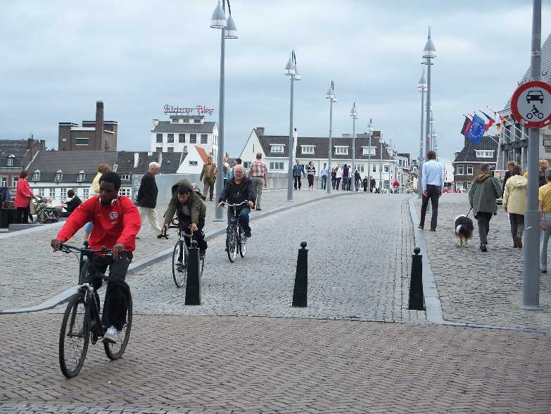
19 – Maastricht City Centre Bridges | 20 – Maastricht – Old Bridge

Maastricht provides another interesting example of filtered permeability. There are four bridges over the river Maas around the city centre. Of these the outermost pair, over a mile apart, form part of an inner ringroad. The two central bridges are shown on figure 19. The one in the background is a purpose-built pedestrian and cycle bridge. The old bridge in the foreground, also shown on figure 20, has evidently been closed to motor traffic in recent years. This arrangement contributes to the largely carfree nature of the city centre on the western bank.

- Belgium – General

Like many other things in Belgium, transport policy and the propensity to cycle vary considerably across the linguistic divide. People would frequently tell me that Dutch-influenced Flanders was considerably more oriented towards cycling, and being richer, also provided better cycling facilities. My impressions tended to confirm this, but it did not seem as ‘black and white’ as people believed.

It should be noted that Flanders is generally flatter than Wallonia, which includes the Ardennes, although there are also many flat parts of Wallonia.

When I returned, I found Hubert and Toint (2002), whose national survey confirmed the view of a clear dichotomy between the regions, showing the following proportion of trips in the morning rush hour, for example:

 | Flanders | Wallonia | Brussels
Cycling | 16% | 2% | 1%
Car as Driver | 49% | 50% | 43%

A map of cycling rates by province showed why my route did not reveal such an extreme difference. The highest rates appear to be in the Flemish provinces adjoining the Dutch border (and along the coast), which I did not visit, whereas, the Flemish provinces close to the linguistic frontier, which I did travelled through, exhibit lower rates. Hubert and Toint refer to this Dutch proximity effect as “cultural contagion”. Although not as consistent as the Netherlands, the Dutch influence could be seen in the parts of the Flanders which I did visit. By contrast, Wallonia appeared to be influenced by the French culture, which sees cycling more as a sport than a means of transport.

  - Regional Cycle Networks

There is no national cycle network in Belgium. There are effectively two regional networks. There are a variety of mapping and signposting conventions, which can be confusing for a visitor, particularly as appropriate maps are not always easy to find.

Across much of the country, mainly but not exclusively in Flanders, there is a signposting system which works by numbering points on every route, so the signposts either indicate a point, or the direction to it. This system works reasonably well providing you have a map showing the points; these are not always easy to obtain, and awareness of these networks is low amongst non-users: I found it was often a waste of time asking directions to paths which local people – including one on occasion, a cycle hire operator – did not even know existed.

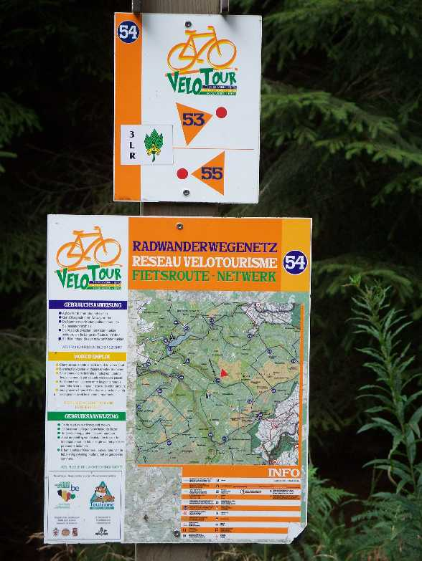 | 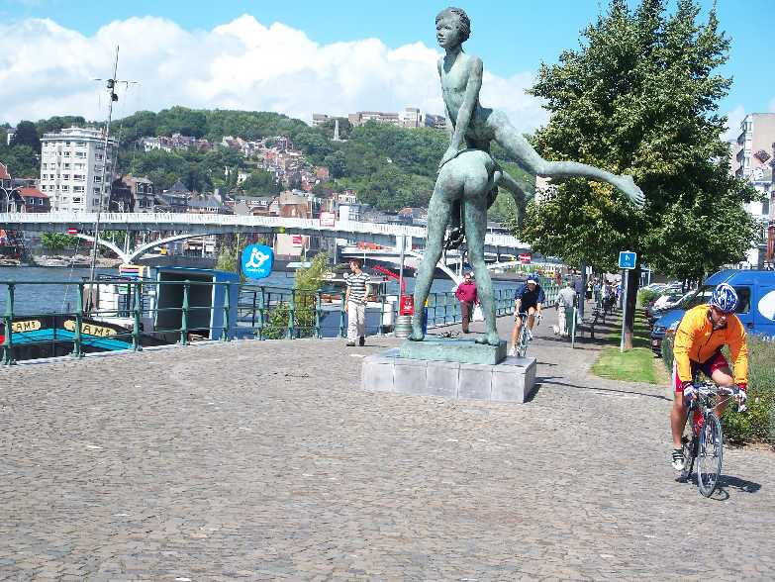
21 – Point based signposting (Regional Park – Forest of Les Hautes Fagnes) | 22 – RAVEL network running along the River Meuse in Liege

Within Wallonia there are two networks, the RVs, which are mainly signposted on existing roads and the RAVEL long distance routes, particularly using old railway paths and particularly waterways. The former were circuitous, illogical and difficult to follow. The latter were often very useful. The systematic use of long-distance waterways, entering, crossing and leaving towns and cities on traffic-free routes, was one of the best aspects of cycling in Belgium (e.g. figure 20).

Apart from this, cities such as Brussels and Liege (and Lille, just over the French border) have fragmented cycling networks, similar to many British cities. Frequent use of cobbles makes riding on the roads difficult in many places. Despite evident efforts by the municipal authorities, the conditions are simply not good enough to encourage the growth of a cycling culture.

  - Hasselt

Hasselt, population 70,000, is of interest from a transport perspective, because of a decision in 1997 to provide free (bus) public transport and reduce road capacity on the inner ring road creating a cycle and bus route.

The local buses are free for everyone. The regional buses are free for residents within the city boundaries. This policy (accompanied by an expansion of the bus network) led to an immediate increase in public transport patronage. Patronage in 2001 across all the networks was 6 times greater than in 1996 (Lambrechts, 2005). The difference was particularly great on the local buses.

As observed elsewhere, much of this increased patronage appeared to be at the expense of walking and cycling. A survey found 16% of passengers had switched from the car compared to 12% from cycling and 9% from walking. I have not been able to find overall modal share statistics. Hasselt has one of the highest levels of car ownership in Belgium, which was identified as a contributor to the problems in the first place

The ‘Green Boulevard’ as the inner ringroad is now called, is one-way for private motor vehicles, punctuated with bus lanes and bus stops (figure 23). For cyclists, the level of segregation is variable. It is not as easy to ride around as Muenster’s Promenade (see figure 15) and is not so well used. The rest of the city has a reasonably good cycling network, though not quite at Dutch levels

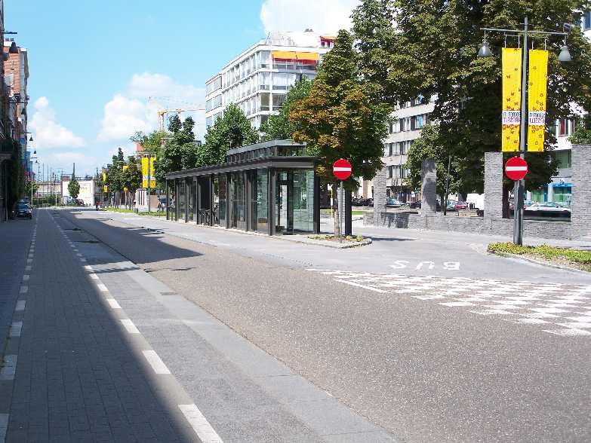 | 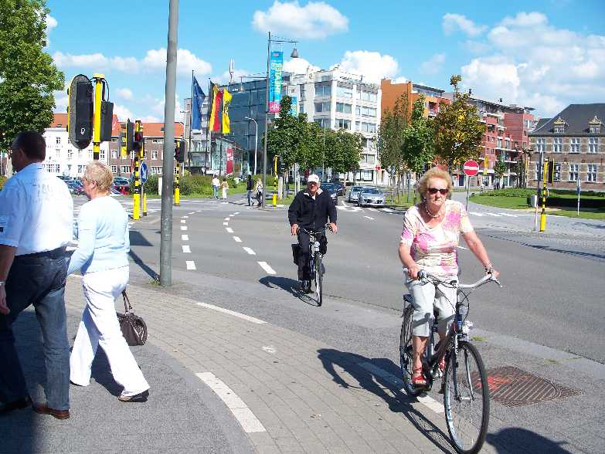
23 Hasselt Green Boulevard | 24 Hasselt Green Boulevard

- Sweden – Malmö

When in Copenhagen I visited Malmö (population 282,000) for an afternoon, taking the new rail link (cycling is not permitted across the bridge). I planned to visit the ‘eco quarter’ of Augustenberg, which proved to be of little interest from a transport perspective. The new Western Harbour development (figure 25), though not carfree, provides an impressive example of urban renaissance and diverse architectural styles. Being surrounded by water on two sides it forms a natural cul-de-sac, which has helped its largely pedestrianised feel.

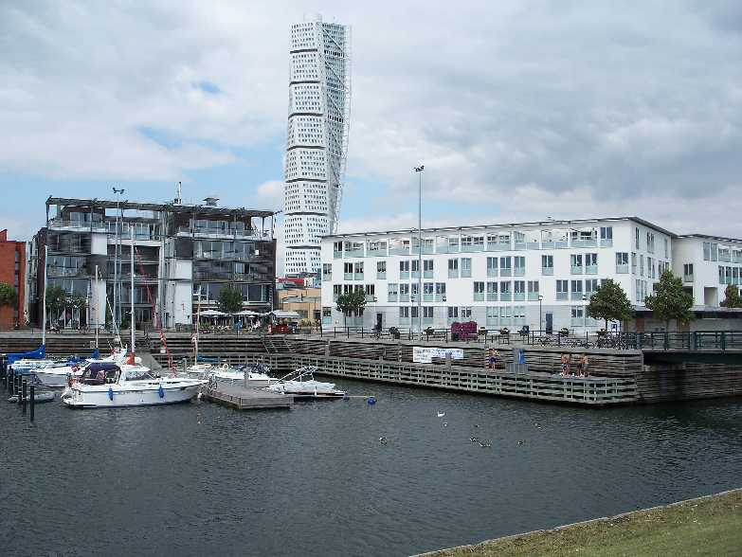 | 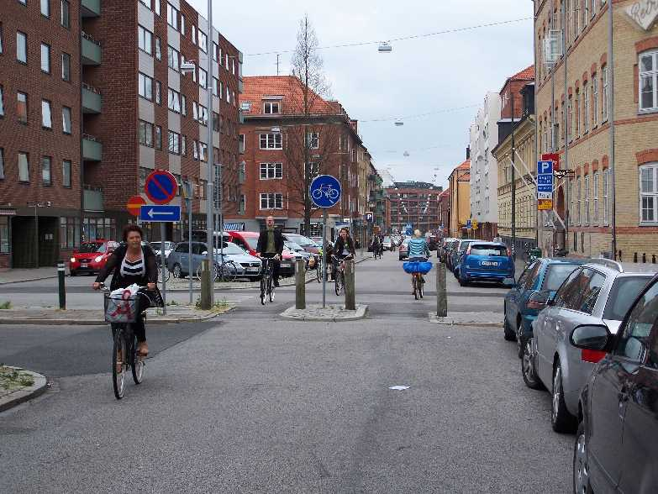
25 – Malmö Western Harbour | 26 – Malmö filtered permeability

Levels of cycling appeared comparable to Danish levels. Filtered permeability appeared to be a deliberate policy, with a combination of bollarded roads and separate paths helping to create cycle routes in and out of the city centre (figure 26). Public transport within the city was entirely bus based, rail being used more for regional travel, particularly commuting to Copenhagen.

References
HUBERT, J. and TOINT, P., 2002. La Mobilité quotidienne des Belges. Presses universitaires de Namur.
LAMBRECHTS, D., 2005. Mobility Policy in Hasselt. City of Hasselt.
LIGERMOET, D., 2006. Continuous and Integral: The Cycling Policies of Groningen and Other European Cities. 7. Rotterdam: Fiets Beraad.
MELIA, S., 2008. Neighbourhoods Should be Made Permeable for Walking and Cycling But Not for Cars. Local Transport Today, January 23rd. on: www.stevemelia.co.uk/articles.htm
MELIA, S., 2007. Eco Town Mobility. Town and Country Planning, November.
PUCHER, J. and BUELHER, R., 2007. At the Frontiers of Cycling: Policy Innovations in the Netherlands, Denmark and Germany. World Transport Policy & Practice, 13(13),.
TCPA and DCLG, 2008. Eco-Towns Transport Worksheet. Town and Country Planning Association.

